
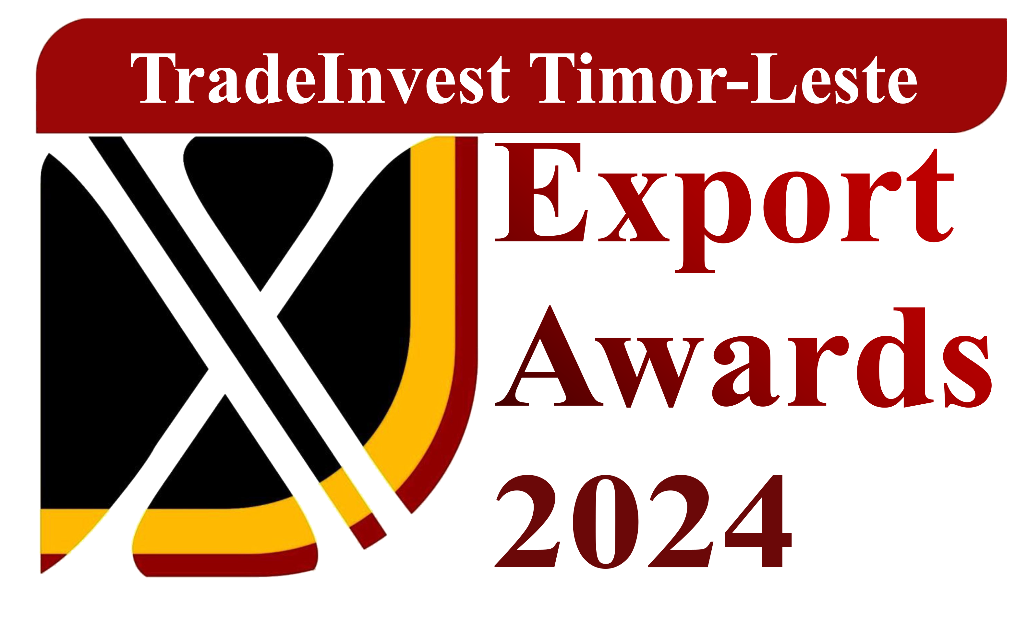
TradeInvest Timor-Leste

APPLICATION

Category 3: Youth Social Business Startup
NOTES TO FILL IN THE APPLICATION

- Choose or apply for a category that is relevant with your business
- A company is eligible to apply for one category only
- Digital or typed application is preferred, hand-written application is not acceptable
- To receive an application form, please email araujojosefina@gmail.com and emilia.ana243@gmail.com or visit the TradeInvest office in Colmera or can be downloaded from TradeInvest’s official website (www.tradeinvest.tl) and Facebook page TradeInvest Timor-Leste.
- Applications are submitted online via email to araujojosefina@gmail.com no emilia.ana243@gmail.com with subject line: 2024 Export Award Application
- Please pay attention to the word limit and weight for each question when answering questions
- Please submit the required documents. Please refer to the documents checklist sheet.
- Answers can be in bullet point form if this helps you to articulate your answers more clearly.
- Application must be submitted before 25 October 2024 at 17:30 Pm. Late application will be rejected

Company’s name :
Contact person/position :
Telephone number :
E-mail /website :
Company’s address :

Business sector (please tick the most relevant one):
Agriculture (horticulture)
Fisheries (aquaculture)
Tourism
Processing industry
Others (please specify: __________________________)

Business size category (please tick the most relevant one):
Small enterprise
Medium enterprise
Large enterprise
SECTION I

INTRODUCE YOUR COMPANY (Weight 25%)

1.1. Describe what your business does (brief history & challenges) and how your business contributes to solving issues facing the community (Word limit: 150)

1.2. What products and/or services you are selling/offering? (Word limit: 150)

1.3. What makes your products/services unique and competitive? (Word limit: 150)

SECTION II

BUSINESS MODEL (Weight 25%)
2.1. How is this business able to sustain financially? (Word limit: 150)

2.2. Where does your source of revenue come from? (Word limit: 150)

MARKETING PLAN /GROWTH STRATEGY (Weight 25%)
2.3. Explain your current business successes this year (2023/2024) – this may include customers/contracts acquired, market expansion, new products/services developed, improved distribution channels, new product lines, investment in staffing resources, new business practices, and any other innovations. (Word limit: 150)

2.4. What is your growth target for next year? Please describe in details your plan/strategy to scale your business for breaking into international markets. What growth strategies have you employed or will employ? Is it price, product or promotion or a mixture? What were the key relationships you have developed? (Word limit: 250)

2.5. How will your international marketing strategy be implemented? What activities will your business undertake in 2023/2024 to support your marketing strategy?
Please tick all relevant activities that are applicable to your business:

Online marketing activities Please give example:
Mission/trade shows Please give example:
Product specification Please give example:
Market research Please give example:
Advertising Please give example:
Communications to stakeholders Please give example:
Partnerships Please give example:

2.6. What will be the key results of your international marketing strategy? – List the key outcomes that will be measured in relation to your marketing strategy (e.g. market share, sales growth, increase in enquiries, customer database, positive customer/client feedback, media coverage, social media coverage, referrals,etc.) (Word limit: 250)

2.7. International sales figures
What is the range of your total DOMESTIC sales revenue for the past 3 financial years (2022,2023,2024 please tick the most relevant one):
Less than US$1,000
Between US$1,000 – US$5,000
Between US$ 5,000 – US$10,000
Between US$10,000 - US$50,000
More than US$50,000

SECTION III

BUSINESS OPERATIONS & HUMAN RESOURCES (Weight 25%)
3.1. International business planning and direction
This is where you should demonstrate your business’ vision and commitment to export. Please provide an insight into the future direction and forecasts of your international business activities over the coming 12-18 months, as outlined in your business plan, and the measures in place to make your international markets sustainable. (Word limit: 200)

3.2. Employment numbers based on financial year data
Applicants are asked to identify the total number of local Timorese and foreign employees for the last 3 financial years
2022 ____________________________________
2023____________________________________
2024 (January - September)__________________

3.3. Financial data
Applicants will be asked to attach financial reporting data for the past three (2022, 2023, 2024 January - September) financial years. Applicants will need to identify the organization’s net profit (after tax), assets, total domestic sales revenue and liabilities.

